CSE 140L
Lab Assignment 2 Alarm Clocks

Introduction
The goal of this lab is to familiarize you with sequential logic design and simulation. We shall use Quartus for synthesis and Modelsim for simulation.
Your task is to implement an alarm clock. This assignment comprises three parts. In the first part, you will implement a conventional alarm clock, which tracks and displays hours, minutes, and seconds. In the second part, you will take what you have learned to extend the alarm clock functionality to include day of the week. For part 3, add month and date.
A library containing several pre-designed components with which you can build your alarm clocks will be provided. We shall also provide you the behavioral simulation transcript and top level structural diagram.
In all parts, it may be helpful to draw a behavioral diagram of how this alarm clock functions and how that maps to its structure.
The deliverable requirements are specified at the end of each section. You will also need to answer some questions in a report according to the instructions. Electronic submission details are on the Gradescope page.

Part 1: Basic Alarm Clock
Behavior: At its simplest, an alarm clock has two functions – keeping track of the current time and buzzing when the current time matches the alarm time. We need to be able to program the alarm time and the current time. Setting the current time and setting the alarm time are very similar tasks, with similar implementations in hardware.

Keeping track of the current time is straightforward. At least in the initial formulation, we shall keep track of hours, minutes, and seconds, and leave days and dates to subsequent parts. The relationship between the three units of time is captured in Figure 1, wherein the eccentric yet subtly elegant Babylonian system of 24 hours, 60 minutes and 60 seconds which we conventionally use is described.

The buzzing part of the alarm is an equality check between the minutes and hours of the current time and the alarm time, complete with an AlarmOn switch that is used to turn the buzzer on and off, in case the user doesn't want to be rudely awakened on a day of leisure (See switch “S5” in Figure 2 and Figure 4). The setting of the alarm time and the current time is shown in Figure 3. The user will enable the setting of the time with a pair of switches, TimeSet (switch “S1”) and SetAlarmTime (Switch “S2”). If neither switch is on, the user will be unable to set either; otherwise, the user will be able to set the current time if SetCurrentTime is on, or the alarm time if SetAlarmTime is on. While the user is setting either the current time or the alarm time, a pair of switches (actually “pushbuttons”, as we will see), MinAdv (Switch “S3”) and HrsAdv (Switch “S4”), will be used to increment the hours and minutes, respectively. When TimeSet = 1, the seconds counter will hold/freeze. When TimeSet=0, the seconds counter will increment once per rising edge of PULSE (our digital clock signal).

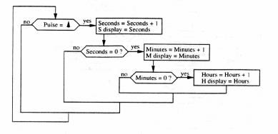

Figure 1: Clock Tick Behavior

Structure: Now that you see the behavioral description of the alarm clock, it is time to move on to a structural description. For the purpose of this exercise, the structural description can be thought of as comprising two parts: the components used to build the clock and their interconnections.

The best way to determine the required components is to look at the behavioral description and identify functionalities that map to known hardware components. Looking at the behavioral diagram of Figure 1, one realizes that a component is needed that will keep track of the time and increment it appropriately with each passing unit of time. This component should increment the seconds on a clock pulse. When the seconds reach 59, instead of being incremented to 60, they will roll over to 0 with the minutes being incremented. Similarly, the minutes, when incremented past 59, will roll over to 0 and trigger the hours to be incremented, which will in turn roll over from 23 to 0 as necessary. For the first part of this exercise, no further increments of other counters are required upon rolling over of the hours.

The behavioral description in Figure 2 that illustrates the buzzing functionality necessitates an equality check between the current time and alarm time. This may be achieved with a simple comparator module, which can compare two pairs of 7 bit values corresponding to the alarm time and the real time.

Figure 3 illustrates the behavioral description for setting the correct time. To complete the implementation of Figures 2 and 3, you need an analogous component to set the alarm time.

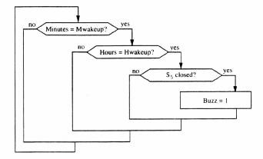

Figure 2: Alarm Buzz Behavior

You will also need a MUX. A MUX, short for multiplexer, is a circuit component which acts as a “decider” among possible output alternatives. The MUX receives 2 inputs, each of which may be multiple bits, and outputs one of them based on a third input S, or “Select”. The reason for including this component is perhaps not as evident from the behavioral description that we have provided you. One issue is that while an Alarm Clock normally would display the current time, when you are setting the alarm time, it would be necessary to have the clock display the Alarm Time so that you know how close you are getting to the desired alarm time. So, a MUX will be needed to switch between displaying the current time (most of the time) and displaying the alarm time (when the user is setting the alarm time).

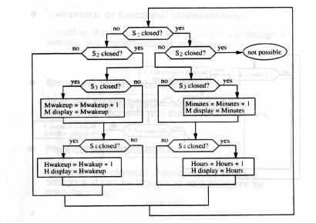

Figure 3: Time and Alarm Set Behavior
TimeSet and AlarmSet together determine the functionality that the user is interested in. In Figure 3, these two switches are modeled by S1 and S2, respectively. When both SetCurrentTime and SetAlarmTime are off (we shall use the notation “(S1, S2) = (0, 0)”), the clock should passively tick and display the current time. If (S1, S2) = (1, 0), the user should be able to set the current time (the display should show the current time). If (S1, S2) = (0, 1), the user should be able to set the alarm time (the display should show the alarm time, so that the user can see it as it changes.) (S1, S2) = (1, 1) will increment/advance both alarm and time S2) = (0, 0), while displaying only alarm. The selection of functionality can be implemented by using a decoder, which expands a binary input into a one-hot encoding scheme.

Now that we have taken a high-level look at the components, it's time to guide you through their interconnections to complete our structural analysis. One way to think about it is to start from the outputs. What is the expected computation of the circuit? The final outputs of the alarm clock are supposed to be a time (typically the current time, but occasionally the alarm time) and a signal indicating the status of the buzzer. You will therefore need some LCD displays. Then, we can ask where do these display components receive information from? The LCDs, for example, must output either the current time or the alarm time depending on the switches TimeSet and AlarmSet. Thus, the inputs of the LCD come from multiplexers which will choose between clock time and alarm time based on the system configuration. We ask ourselves again about the multiplexers: where do they receive inputs from? After mulling the question recursively, we come down to the base case at primary inputs – the clock, buttons and switches which are used to control the clock by the user.

An approximate high-level structural schematic that embodies this discussion is presented in Figure 4.

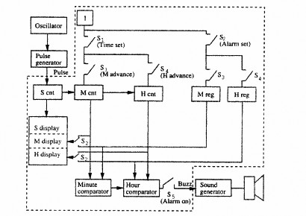

Figure 4: Alarm Clock Structural Schematic
Figure 4 comments: 1) If Timeset (SetCurrentTime) = 0, S cnt increments on posedge Pulse. If Timeset = 1, S cnt freezes. 2) M cnt increments on posedge Pulse if Szero flag from S cnt = 1 OR if TimeSet = MinAdv (IncMinute) = 1.

Input/Output: The inputs to this simple alarm clock we’re developing are: AlarmOn, SetCurrentTime and SetAlarmTime, and the HrsAvd and MinAdv pushbuttons. You should also have a binary switch Reset” hooked to the Reset input to be able to reset all counters to 0. The outputs will be the current time (or alarm time) on the LCD Displays and the state of the buzzer. No additional inputs or outputs should be necessary for this device, nor should they be included.

Implementation hints:
  - You should use a Binary Switch to activate the alarm functionality (AlarmOn). (Refer to switch S5 in Figure 2 and Figure 4.)
  - You should implement the logic that will enable the user to set the alarm time and the current time. You should use two switches (Refer to switches S1 and S2 in Figure 3 and Figure 4) and a decoder component, to implement the following cases:
    - If S1=1 and S2=0, then the user can set the current time;
    - If S1=0 and S2=1, then the user can set the alarm time;
    - If S1=S2=1, then time and alarm are both being set, but only alarm will be displayed.
    - Otherwise, no user modifications to current time or alarm time take place.
  - There will be an output for the BUZZER that will go high when the alarm is on, and the hours and the minutes of the clock match the alarm setting. If the user turns the alarm off, the BUZZER signal should go down.
  - To display the time, you should be using LCD displays connected to an LCD Interface. There should be one single set of LCDs, as in our regular alarm clocks, which shows the alarm time only when we select that switch to set the alarm time. You can use a MUX to select between the inputs.

Part 1 Deliverables:
  - All of your Verilog source text (.sv) files, and a Verilog source testbench (.sv) showing correct functionality
  - In the pdf format report, explain how you tested your alarm clock and including:
    - A screenshot of the RTL viewer top level schematic/block diagram in Quartus
    - A screenshot of the Modelsim transcript, showing correct alarm functionality
  - Project files (mpf, qpf) and waveform view (wlf) files are not required.

Part 2: Days of the Week

Your next task is to extend the functionality of the alarm clock to also track and display the days of the week. Using your expertise gained from the previous implementation of the alarm clock, you will design and implement this new feature. You may use the original alarm clock implementation as a reference, as this feature is more of an extension of existing functionality rather than a completely unique addition.

However, our implementation of the days of the week will have one special feature. As much of the working world follows a traditional, 5-day work week from Monday to Friday, there is much less incentive to wake up on Saturdays and Sundays. One could simply shut off the alarm feature on Friday evening, but this runs the inherent risk of forgetting to turn it back on before Monday! Your implementation of the alarm clock will remove the risk of user error by automatically disabling the alarm on weekends (Saturday and Sunday), overriding whether the alarm is turned on or not by the user. UPDATE: What if your days off are Sunday and Monday, or even Wednesday and Thursday? This new, improved version of the alarm clock has an alarm day register in addition to the real time day counter, enabling you to choose your own “weekend.” The following table relates the alarm day value with the current day value and whether or not the alarm is enabled for that day.
Alarm Day of Week and Time Day of Week
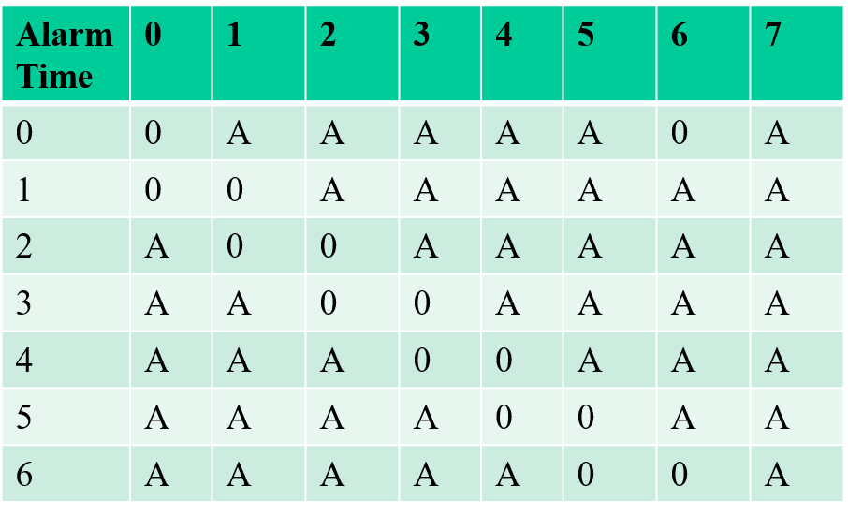

With additional information to be tracked, you will likely need to modify the existing modules that track the current time and the alarm time. Analogous to how the minutes increment when the seconds roll over and the hours increments when the minutes roll over, you will need to have a counter for the day of the week that increments when the hours roll over.

Implementation hints:
- The days of the week will be denoted by numbers 0-6, with 0 corresponding to Monday, through 6 corresponding to Sunday.
The alarm will never buzz on AlarmDay or (AlarmDay+1)Modulo7, regardless of whether the alarm is enabled or not. Thus, if Alarm_Day = 3 and Time_Day = 3 or 4, alarm will not go off (0)

- You will need to add LCD displays to also show the day of the week. The display should show the numerical number of the day of the week (0 for Monday and 6 for Sunday). Only a single digit display is necessary.

- The day of the week should be able to be set independently for the current time, similarly to how the hours and minutes may be set. Similarly for alarm day of week.

- The day of the week also needs to be set for the alarm functionality, since the alarm will activate for all days of the week, except AlarmDay and the day after.

- The testbench from Part 1 has been extended to test for the days of the week functionality.

- Finally, note that setting the AlarmDay = 7 will enable the alarm 7 days per week (no rest for the wicked or those at a startup. 😊

Part 2 Deliverables:
.
  - A set of all necessary Verilog files separate from the files for Part 1.
  - An expanded testbench that covers and checks the day of the week functionality
  - A summary report explaining day of the week enhanement and including
    - A screenshot of the RTL viewer schematic in Quartus
    - A screenshot of the Modelsim transcript, showing correct day of the week functionality

Part 3 Deliverables:

Those aspiring for an A in this course should add a date and month function. These are counters that increment every time the hour rolls over from 23 back to 0. The challenge is that the day counter will be modulo 29, 30, or 31, depending on the current value of the month counter. These run 1 to 12 for month and 1 to 29, 30, or 31 for the date, depending on the month.

